VEHICULAR HEATSTROKE ALERTING SYSTEM

ADITHI PAI-15001

ARVIND P JAYAN-15007

Y V V S SAI PAVAN-15058

# PROBLEM STATEMENT:

Vehicular heatstroke, hyperthermia. The devastating effects of a child being left in a hot car. It's every parent's unfathomable nightmare, yet it happens several times a year. The tragedy can happen almost anywhere, and while hotter months are always the riskiest, the circumstances surrounding child vehicular heatstroke are varied.

According to the safety organization Kids and Cars, an average of 37 children die each year in hot cars. These include instances where a child has been forgotten in a car, accidentally locks themselves in a car or trunk, or, in a small number of cases, when a child has been intentionally left in a car.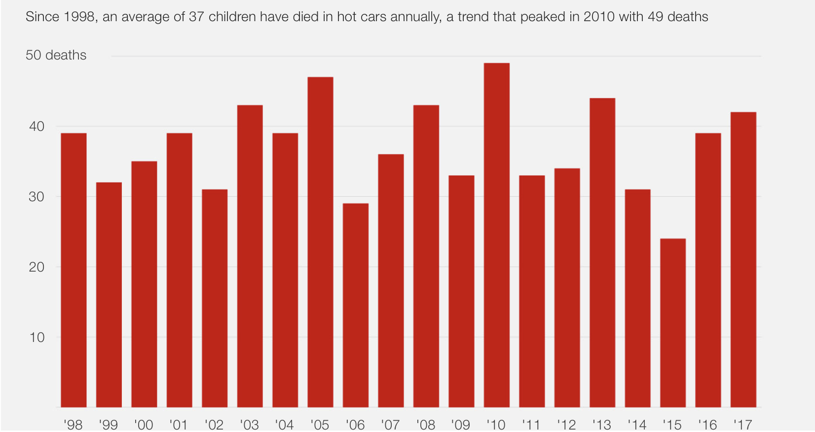

It seems obvious that states with the highest temperatures are usually where the most deaths by vehicular heatstroke happen, but there have been instances recorded in nearly every state.

Similar cases can be found for pets also, as they are to left in vehicles and due to vehicular hypothermia, they die.

# IoT SOLUTION:

Our IoT solution is to create a system to recognize the presence of children, adults or animals inside the vehicle when the vehicle’s engine is switched off. If this happens for a long interval of time and presence of CO/CO2 increases considerably then the required adults will be alerted first, if no action is taken beyond a threshold time local authority will be alerted.

# 

We are using a web cam, sound sensors to detect the presence of kids who are left alone in vehicles, and also if either the temperature, detected by the temperature sensor or the CO/CO2 level detected using air quality gas sensor, then:

If the criticality is less - Alert parents

If there is high criticality - Alert Local authorities and Parents

# ARCHITECTURE DIAGRAM:

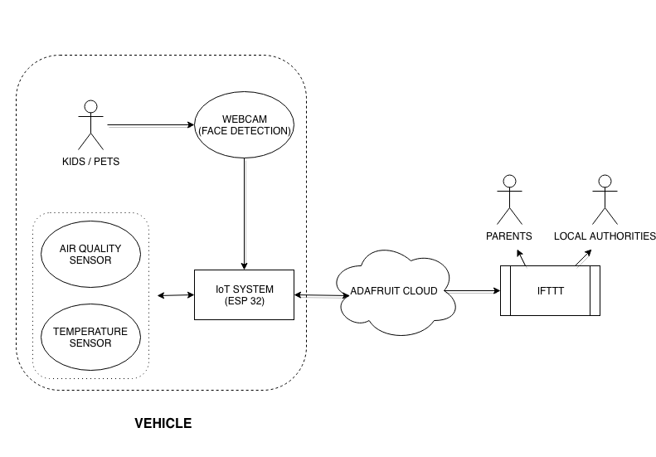

**CIRCUIT DIAGRAM:**

